Accessing user tickets in Zendesk

Overview
Our Zendesk instance now allows end users to access a portal in which all of their tickets are available for view, and interaction. This is especially useful for end users that juggle multiple issues at a time with Applitools support.

Instructions
- Navigate to https://help.applitools.com/hc/en-us and click Sign in in the top right hand corner.
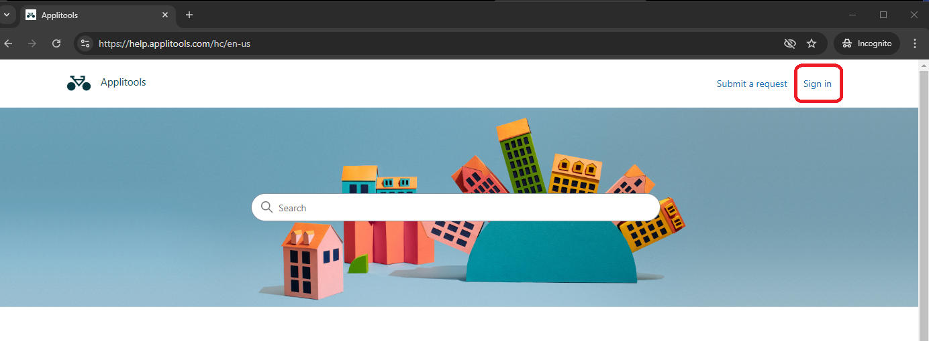
- If you are an existing user, you will have to create a password to associate with your email. Click “Forgot password?”.
- Enter your email in the “Email *” field, and click Submit.
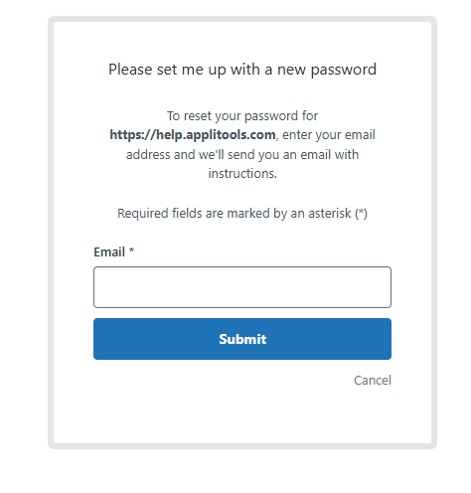
- Follow the instructions in the email you receive. Click “Set a new password”.
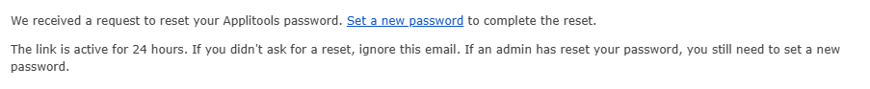
- Enter your desired password in the “New password field”, and click “Change password”.
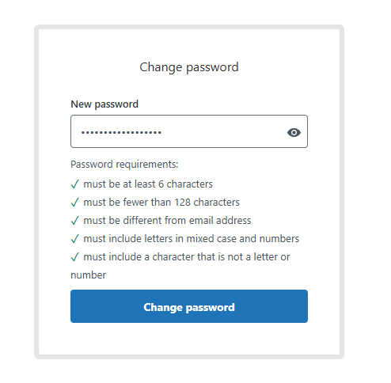
- You now have an accessible user portal in the upper right hand corner of the page. Click the dropdown and click “Requests”.
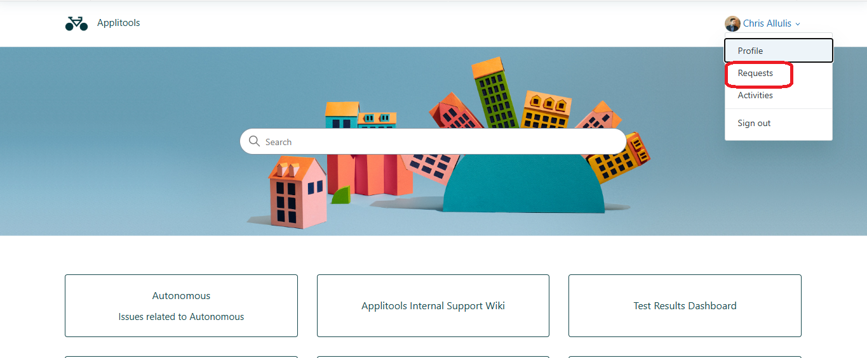
- This page contains a list of all requests that you requested.
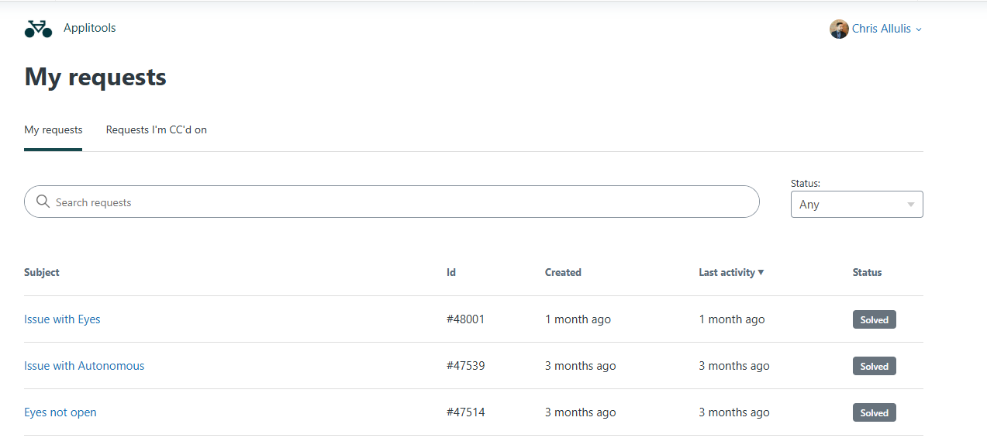
- Each ticket view allows you to view the conversation history, status, and some associated metadata. You can also handle all communications in this view.
